Ladies Uniform Tops Grades 9+

- School Uniform Short Sleeve Mesh Polo Shirt
$18.95-$24.95

Item #: 550329-BP4

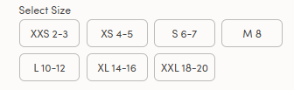
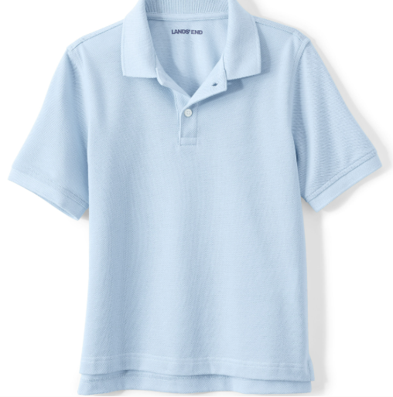

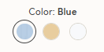

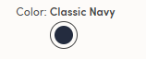

- School Uniform Short Sleeve Interlock Polo Shirt
$22.95-$28.95 #529185-BP6

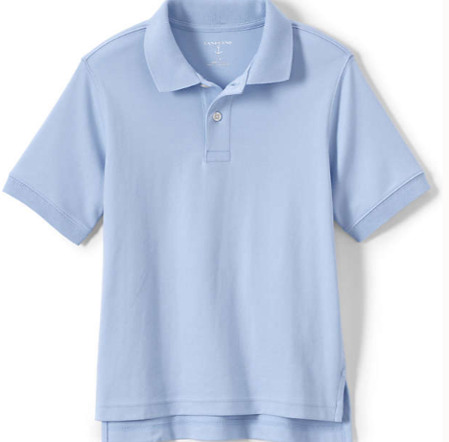

- School Uniform Long Sleeve Interlock Polo Shirt
$25.95-$34.95 #B29188-BPX
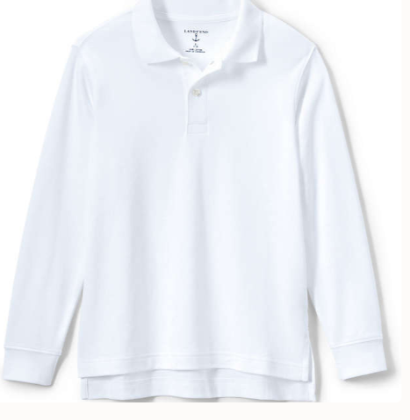

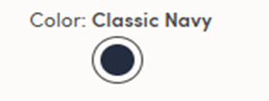

- School Uniform Long Sleeve Mesh Polo Shirt
$22.95- $29.95 #550325-BP6
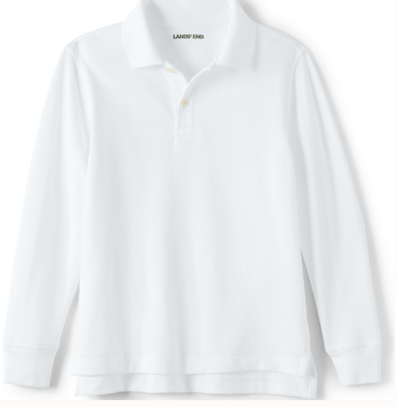

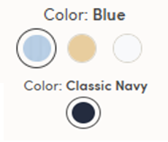

5.School Uniform Girls Short Sleeve Feminine Fit Interlock Polo Shirt
$22.95-28.95 #529347-BP6

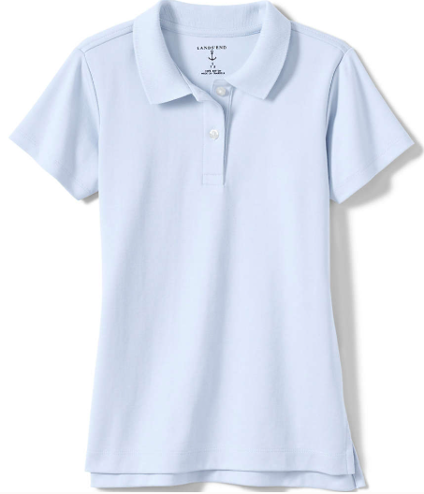
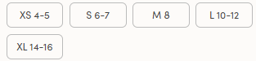

- School Uniform Girls Long Sleeve Feminine Fit Interlock Polo Shirt
$25.95-34.95 #529348-BP0
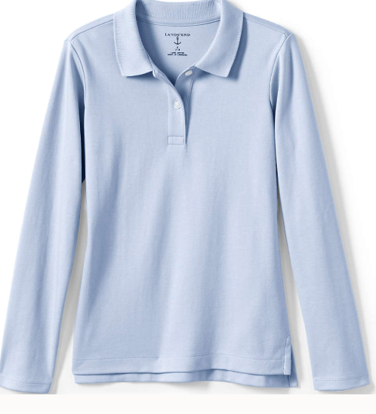
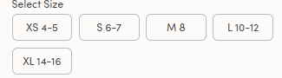

- School Uniform Girls Long Sleeve Feminine Fit Mesh Polo Shirt
$22.95-29.95 #529346-BP1
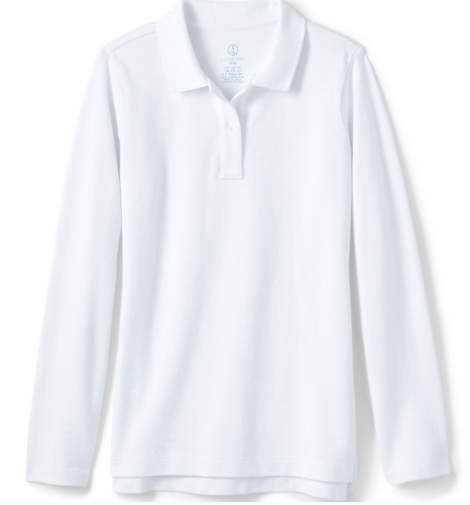

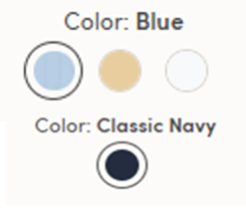

- School Uniform Girls Short Sleeve Oxford Dress Shirt
$24.95-29.95 #528919-BP9
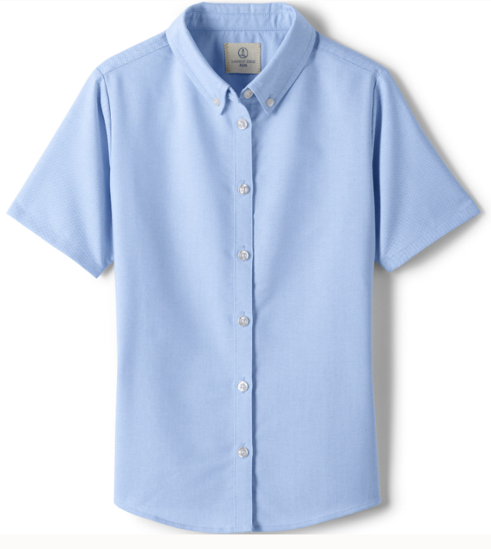
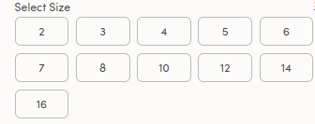



- School Uniform Girls Long Sleeve Oxford Dress Shirt
$29.95- 37.95 #528924-BPX
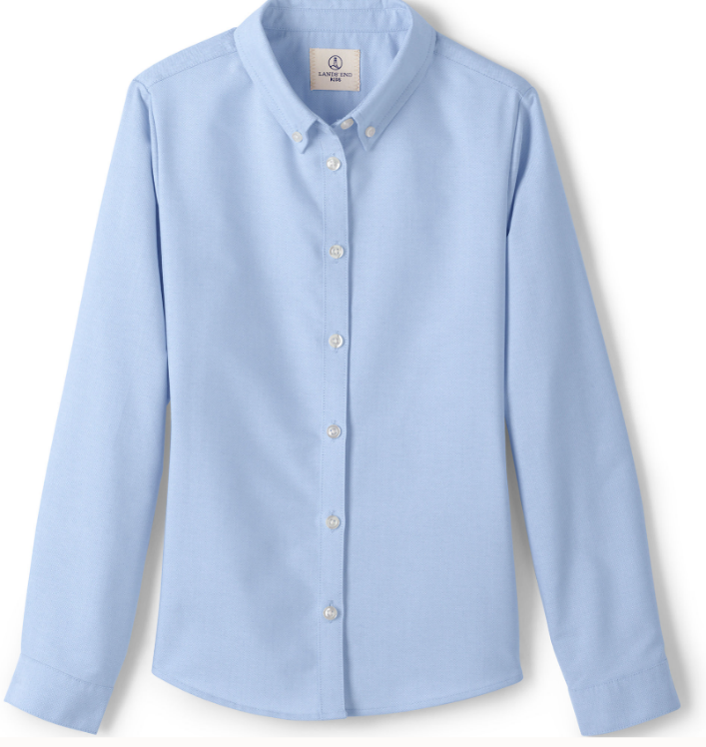



- School Uniform Girls Cotton Modal Button Front Cardigan Sweater
$47.95-$57.95 #528921-BP6
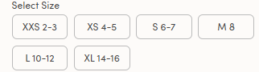
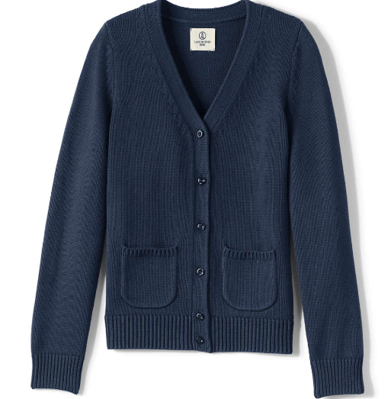

- School Uniform Girls Cotton Modal Cardigan Sweater
$39.95-49.95 #528922-BP0
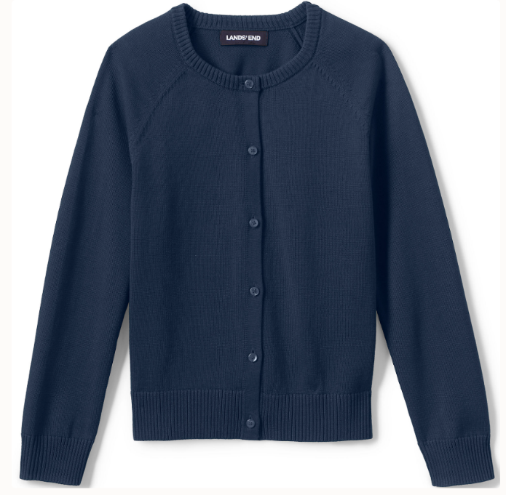

- School Uniform Boys* Cotton Modal Fine Gauge V-neck Sweater
$39.95- 49.95 #529204-BP5

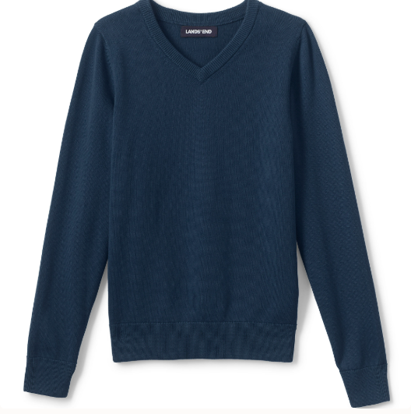
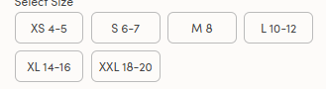

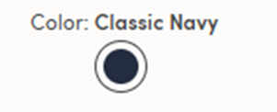

- School Uniform Cotton Modal V-neck Sweater
$44.95-54.95 # 529220-BP4

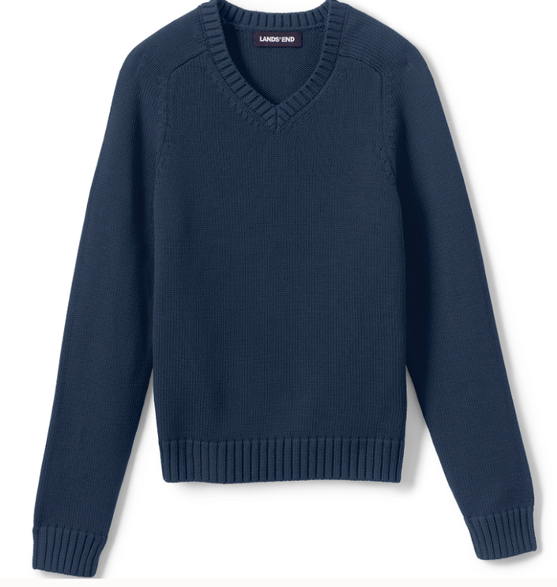
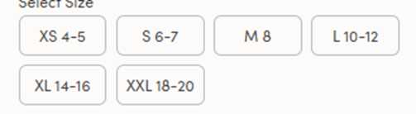

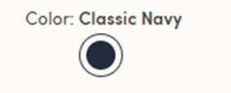

- School Uniform Girls Hopsack Blazer
$93.95-$163.95 #528157-BP2
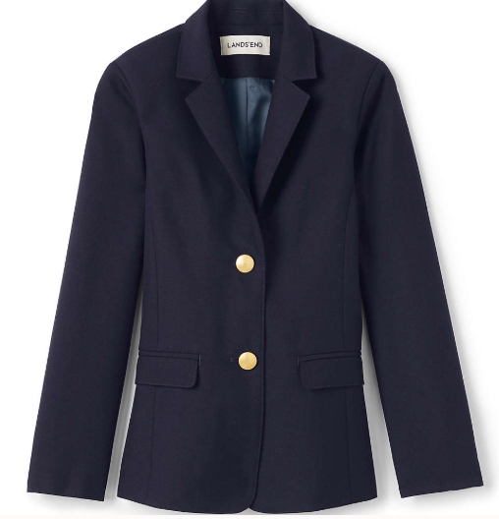
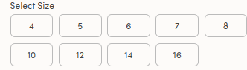

Ladies Uniform Bottoms Grades 9+

- School Uniform Girls Ponte Pleat Skirt at the Knee
$26.95-31.95 #527955-BP3
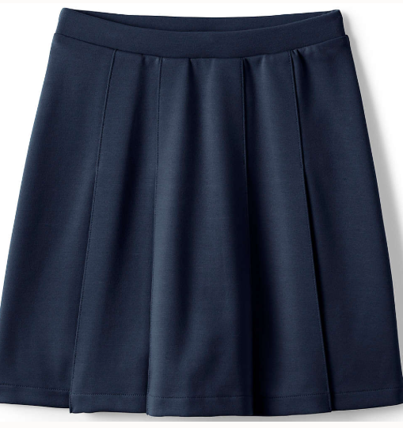



- School Uniform Girls Plaid Box Pleat Skirt Top of Knee
$ 43.95-$48.95 #527964-BP2
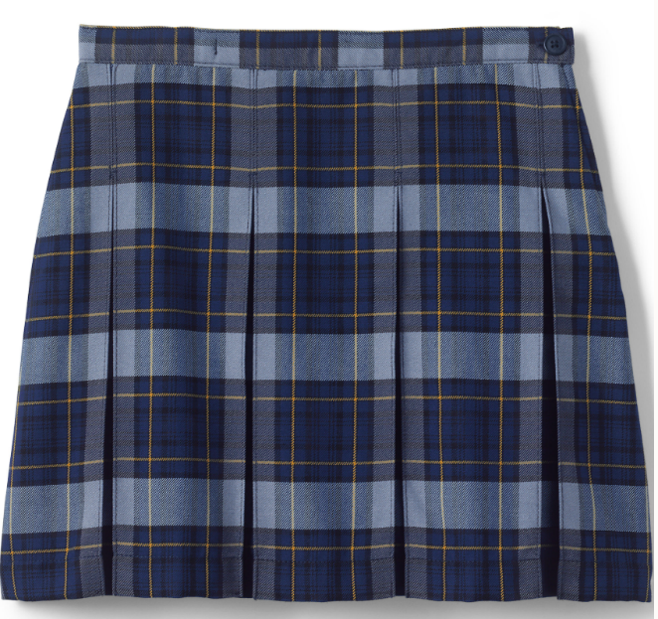



- School Uniform Girls Iron Knee Blend Plain Front Chino Pants
$34.95-39.95 #528965-BP9
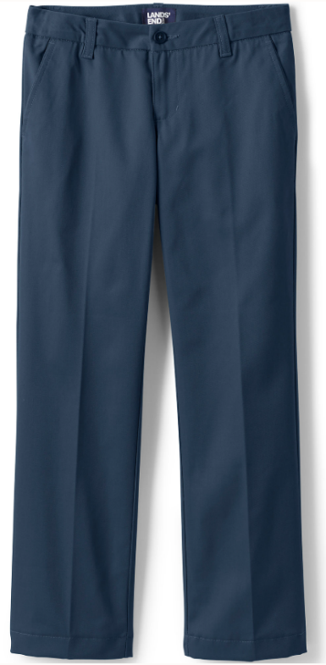

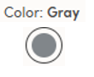

- School Uniform Girls Plain Front Dress Pants
$48.95- #528113-BPX
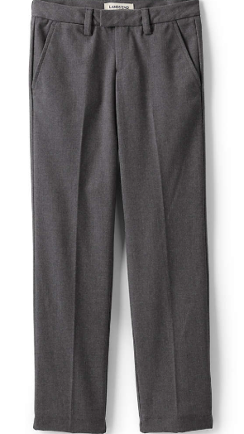

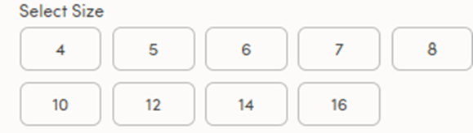

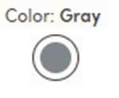

- School Uniform Kids Reversible Belt
$22.95 #545196-BP9

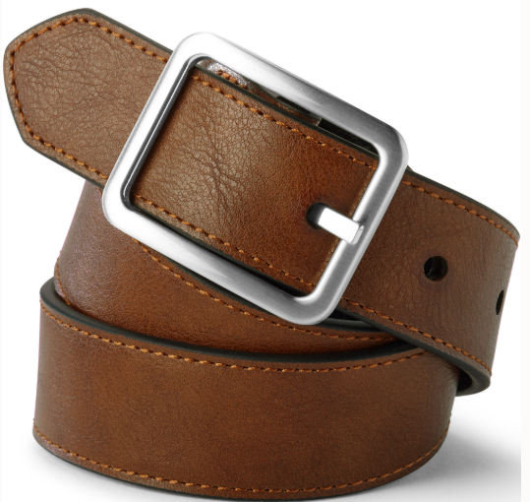
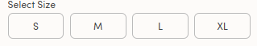



- School Uniform Girls Cross Tie
$14.95 #438994-BP7

