Gentlemen Uniform Tops Grade 9+

- School Uniform Short Sleeve Mesh Polo Shirt
$18.95-$24.95

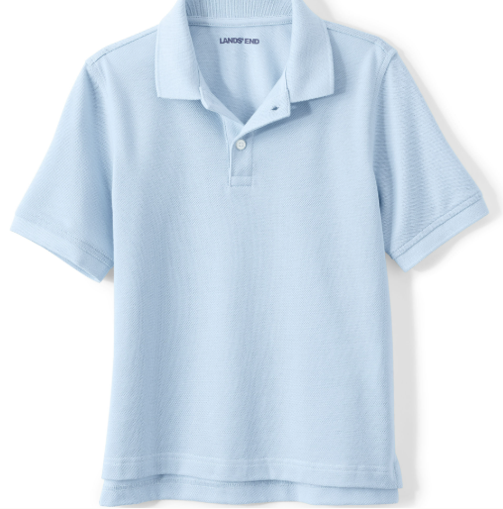
Item #: 550329-BP4

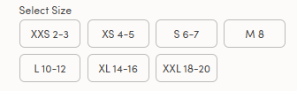

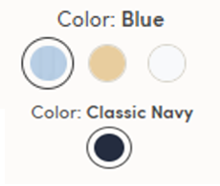

- School Uniform Short Sleeve Interlock Polo Shirt
$22.95-$28.95 #529185-BP6
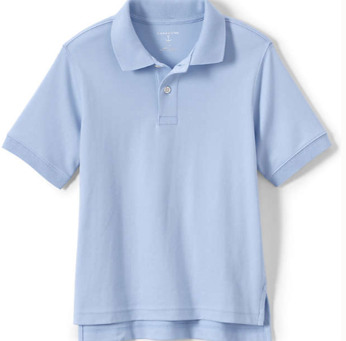

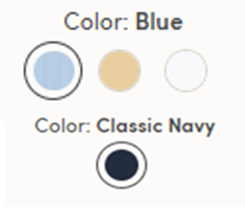

- School Uniform Long Sleeve Interlock Polo Shirt
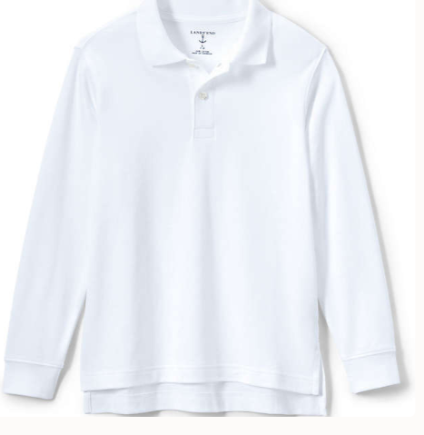
$25.95-$34.95 #B29188-BPX

- School Uniform Long Sleeve Mesh Polo Shirt
$22.95- $29.95 #550325-BP6

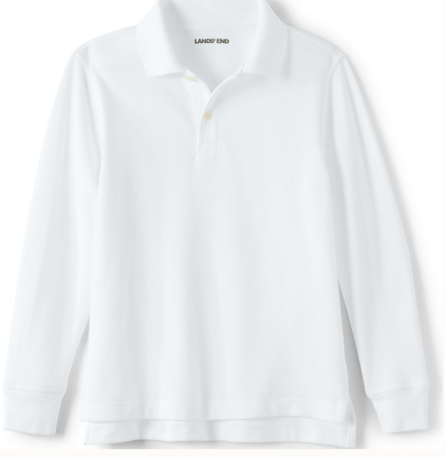

- School Uniform Boys Short Sleeve Oxford Dress Shirt
$24.95-29.95 #529202-BP6
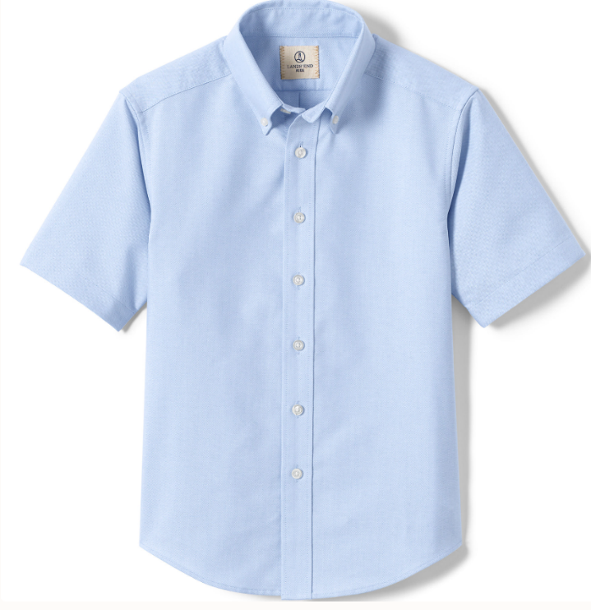
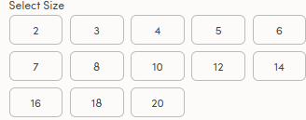



- School Uniform Boys Long Sleeve Solid Oxford Dress Shirt
$29.95- 37.95 #529205-BPX

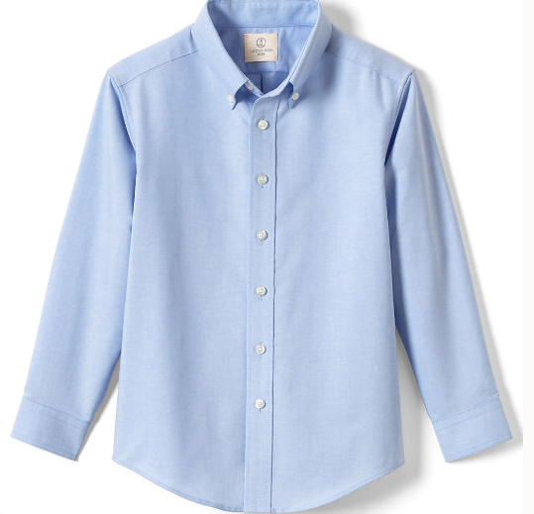



- School Uniform Boys Cotton Modal Fine Gauge V-neck Sweater
$39.95- 49.95 #529204-BP5

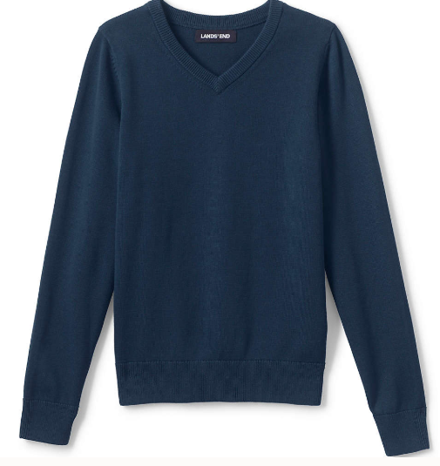
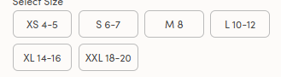

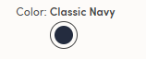

- School Uniform Cotton Modal V-neck Sweater
$44.95-54.95 # 529220-BP4

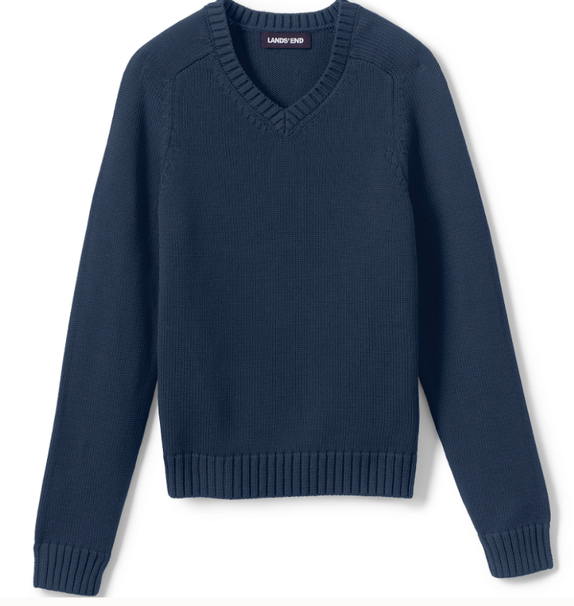
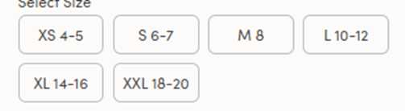

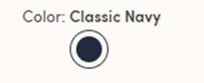

- School Uniform Boys Hopsack Blazer
$$93.95- $163.95 #529175-BP2

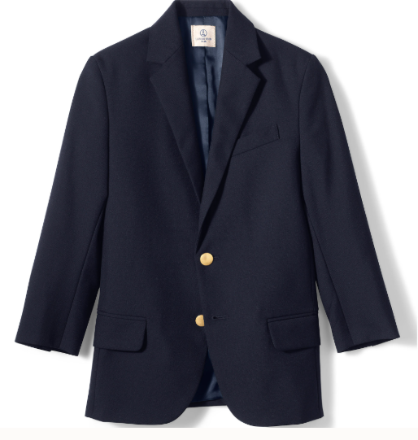
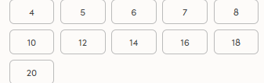

- School Uniform Plaid Tie
$22.95 #426743-BP4
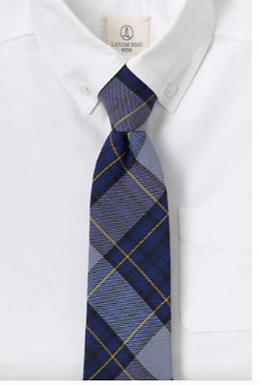

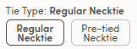



Gentlemen Uniform Bottoms Grade 9+

- School Uniform Boy's Iron Knee Wrinkle Resistant Plain Front Chino Pants
$33.95-$43.95 #529033-BP6
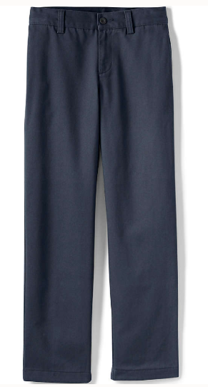

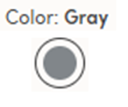

- School Uniform Boys Iron Knee Blend Plain Front Chino Pants
$34.95- $44.95 #529034-BP0
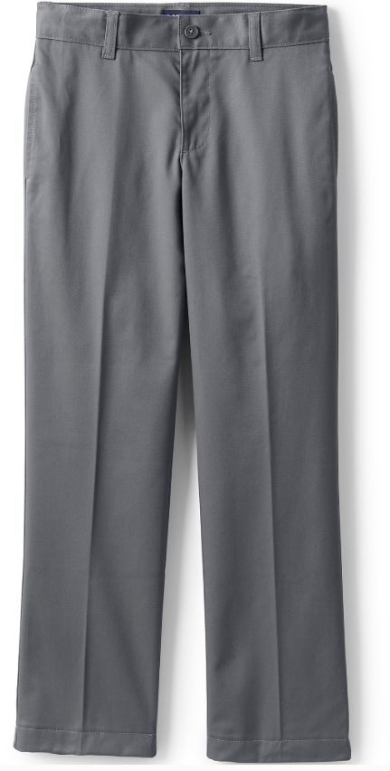
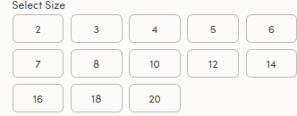

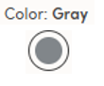

- School Uniform Boys Plain Front Dress Pants
$48.95- $58.95 #529030-BP2

